**MAE 575**

**Introduction to Turbulence and Turbulent Flows**

**Project Assignment**

Due 9:50 a.m. on 1 May 2019

In this project, you will employ a widely-used commercial CFD package (ANSYS Inc. FLUENT) to test the effects of various turbulence models and simulation parameters on the accuracy of the results for a standard test problem that is frequently used to assess turbulence models. Specifically, you will use FLUENT to obtain simulation results for turbulence statistics in the flow over a “backward-facing step”. You will compare the FLUENT simulation results with experimental data for the same flow to see how the choice of turbulence model and simulation parameters affects the results you obtain and their agreement with the experimental data.

The flow you will simulate is the nominally two-dimensional flow over a backward-facing step at the conditions in the experiments of Driver & Seegmiller (1985); AIAA Journal, Vol. 23, pp. 163-171. A description of the geometry and flow conditions is available [HERE](http://cfd.mace.manchester.ac.uk/cgi-bin/cfddb/prcase.cgi?30&EXP&&database/cases/case30&cas30_head.html&cas30_desc.html&cas30_meth.html&cas30_data.html&cas30_refs.html&cas30_rsol.html). The mean (average) velocity field is two-dimensional ( and  are non-zero, but ) but the turbulence is of course fully three-dimensional ( are all non-zero).

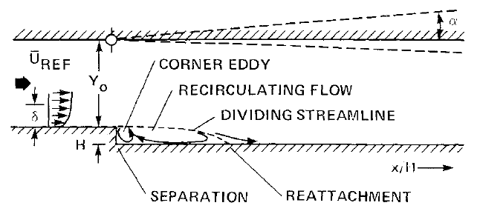

Figure 1. Basic geometry for two-dimensional flow over a backward-facing step. The flow is turbulent throughout the recirculation region immediately downstream of the step, and in the reattachment region farther downstream. Note also the boundary layer approaching the step, and the top and bottom walls. You will consider only the case of a straight top wall.

You will compare the FLUENT simulation results with the experimental data for:

1. First-order turbulence statistics (*i.e.,* the average velocities  and ; recall that  in this flow)

2. Second-order single-point turbulence statistics (*i.e.* the Reynolds-stress components  that were measured in the experiments: , , and ; the experiment did not measure the other three components , , and )

Additionally, you will also examine

3. The turbulence kinetic energy  and the turbulent dissipation rate , for which the Driver & Seegmiller data do not provide values.

You will examine such comparisons in the recirculation zone immediately downstream of the step, and in the reattachment region downstream of the recirculation zone.

Although Driver & Seegmiller made measurements at 12 locations  downstream of the step of height *H* (the step is located at  = 0), and in principle you could digitize their data from Figs. 3-8 in their paper), their data are tabulated [HERE](https://turbmodels.larc.nasa.gov/Backstep_validation/profiles.exp.dat) at  = 1, 4, 6, and 10, so the project only requires you to make comparisons at these four locations downstream of the step. (Several third-order single-point statistics were also measured by Driver & Seegmiller and are tabulated there, but FLUENT does not provide any results for third-order statistics, so we will ignore these.)

The Driver & Seegmiller turbulence statistics are normalized by reference velocity  (the bulk flow velocity approaching the step), so you will make graphs of:

 ,  ,  ,  ,  ,

 and 

Thus, for each of  = 1, 4, 6, and 10 you will graph profiles along 0 ≤  ≤ 2.5 of these turbulence statistics from FLUENT and from the Driver & Seegmiller data. (Note that the tabulated values in the Driver & Seegmiller data for the second-order statistics are multiplied by 1000, so make sure you do the same in your corresponding FLUENT results to allow direct comparisons with the tabulated values.)

You will set up and run FLUENT to explore the effects of the turbulence model, the computational grid, the inflow and outflow conditions, and wall boundary conditions on the resulting agreement with the Driver & Seegmiller data. Follow the basic instructions provided separately on how to set up and run FLUENT to do this. (Note that some values in these instructions differ from those below, but those instructions will help you navigate FLUENT’s user interface.) Under the Reference Values tab, set your step height *H* to be 1.27 cm and *UREF* = 44.2 m/sec, as in Driver & Seegmiller, and under the Materials tab specify air properties ( and ). Note that these values give a Reynolds number based on step height, , of about 37,000.

First, set up the geometry to match key aspects of the Driver & Seegmiller geometry, keeping in mind that you will be conducting a two-dimensional simulation. Place your inflow boundary 10 step heights *H* upstream of the step to allow the boundary layer to develop before reaching the step, and make the inflow boundary 2*H* high. Place your outflow boundary 30 step heights *H* downstream of the step, so the “artificial”outflow boundary condition will not greatly affect your results in the region of interest, which is . Make the outflow boundary 3*H* high. Make your top and bottom walls parallel, which corresponds to the  case of Driver & Seegmiller (we will not examine effects of positive or negative top-wall deflection in this project).

Next, you will set up your mesh. There are many options for creating the mesh, and in general mesh generation is one of the most important factors that influence the results from a simulation. (That should worry you a bit, since ideally the results from a simulation should not depend on the choice of computational mesh, and in most problems you won't have results like those of Driver & Seegmiller to help you know when your mesh is “good enough”!) For simplicity we will use simple quadrilateral meshes. We will generate results on three different meshes: the first of which we will call COARSE, the second MEDIUM, and the third FINE. We hope to see “mesh convergence”, where the results on the two finer meshes are nearly identical, indicating (weakly) that our solution has become “mesh independent”.

On all three meshes, we need a comparatively higher mesh density in the region immediately downstream of the step, since gradients in the turbulence statistics will be large there. We will do this by constructing a “zonal mesh” that splits the simulation domain into five rectangular regions, and constructing a separate quadrilateral mesh for each zone, ensuring the meshes match at the zone interfaces. Zone 1 is upstream of the step. Zone 2 begins immediately downstream of the step and extends 15*H* along the downstream direction and from the step height to the bottom wall. Zone 3 is directly above Zone 2 and extends from the step height to the top wall. Zone 4 is immediately downstream of Zone 2 and extends to the outflow boundary, and Zone 5 is directly above Zone 4 and extends to the top wall.

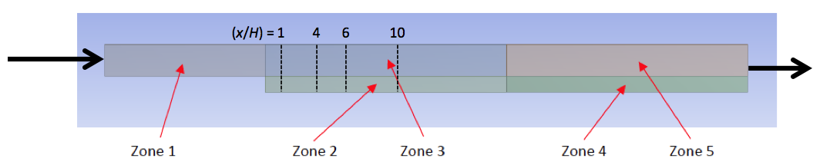

We will refine the mesh more strongly in Zones 2 and 3, since that is where most of the gradients in turbulence statistics occur. Use the following meshes:

COARSE Mesh:

Zone 1: 40 quads along the x-direction and 8 quads along y-direction

Zone 2: 60 quads along the x-direction and 4 quads along y-direction

Zone 3: 60 quads along the x-direction and 8 quads along y-direction

Zone 4: 60 quads along the x-direction and 4 quads along y-direction

Zone 5: 60 quads along the x-direction and 8 quads along y-direction

MEDIUM Mesh:

Zone 1: 60 quads along the x-direction and 12 quads along y-direction

Zone 2: 120 quads along the x-direction and 8 quads along y-direction

Zone 3: 120 quads along the x-direction and 16 quads along y-direction

Zone 4: 90 quads along the x-direction and 6 quads along y-direction

Zone 5: 90 quads along the x-direction and 12 quads along y-direction

FINE Mesh:

Zone 1: 80 quads along the x-direction and 16 quads along y-direction

Zone 2: 240 quads along the x-direction and 16 quads along y-direction

Zone 3: 240 quads along the x-direction and 32 quads along y-direction

Zone 4: 120 quads along the x-direction and 8 quads along y-direction

Zone 5: 120 quads along the x-direction and 16 quads along y-direction

Next, you will specify which turbulence model FLUENT should use. In this project you will generate separate results for the  model,  model, and Reynolds stress transport model (5 eqn). In all cases, use “standard” values for all model constants (e.g.,  etc.); these are the default values, so just leave them as they are.

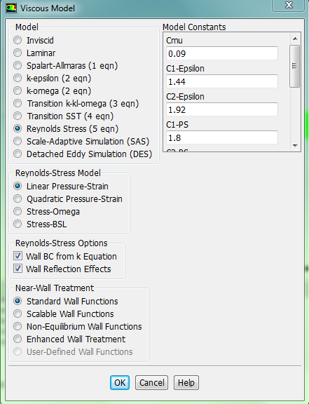

Now specify the boundary conditions. Set your inflow velocity to be  as in Driver & Seegmiller. Specify a constant-pressure outflow boundary condition (this is artificial; in reality the pressure varies somewhat over the outflow boundary). In addition to the no-slip condition on all walls, FLUENT uses “wall functions” to handle the near-wall region (we will discuss these in the course). The choice of wall treatments is available when you are selecting the turbulence model for the simulation. Under the Models tab, select Viscous and Edit to launch the following window, then select “standard wall functions”.

The turbulent kinetic energy *k* and turbulent dissipation rate  at the inflow boundary can be specified under the Boundary Conditions tab. Each is specified in physical (dimensional) form. Set these to a 3% inflow turbulence level, namely  on the inflow boundary, and thus , and to , namely . Select Inlet and then Edit to launch the window shown below, where you need to choose *k* and  from the Specification Method drop-down. The Reynolds Stress Specification Method has two options: "K or Turbulent Intensity" or "Reynolds-Stress Components"; choose *k* and set it as noted above. Finally, under the Materials tab specify air properties (air properties are the default in FLUENT –  and ).

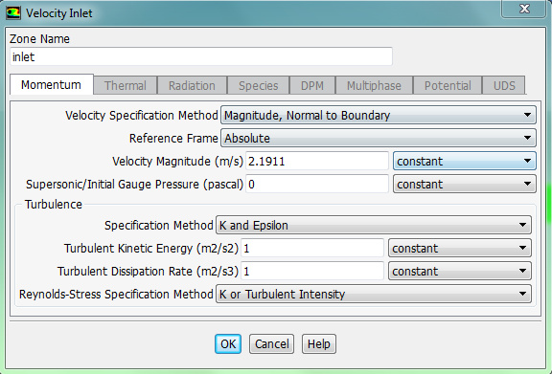

When you have FLUENT use the Reynolds Stress Transport Model (RSTM), it calculates the Reynolds stresses  directly from the governing equations for ; these equations are equivalent to the  transport equations that we discussed in the lectures. FLUENT then makes the resulting  fields available to you as an output option.

However, when you have FLUENT use the  or  models, it calculates the Reynolds stresses  as

 ,

which is exactly the same as , as part of the process of solving the mean momentum equation, but it does not make the resulting  fields available to you as an output option. Instead, you have to have FLUENT calculate them for you as a user-defined function based on the above form.

Project Requirements:

1. Now you are ready to run FLUENT. You have three turbulence models, and three meshes, so you will run nine cases. For each case, export the results from FLUENT for the five turbulence statistics noted above, so you can plot them later using any graphing package you like. For each of the nine cases turn in color fields for the , , , , and  results, and also for the turbulence kinetic energy field  and the turbulent dissipation rate field .

Thus, this section of your report will show a total of 63 color fields (9 pages), each spanning from 0 ≤  ≤ 12 and 0 ≤  ≤ 2. Put all seven color fields for each case on a single page. Each page should have a clear caption identifying the fields being shown, the turbulence model used (, , or Re-stress transport), and the mesh (COARSE, MEDIUM, or FINE). Discuss these results briefly, focusing on the differences in these fields from the three turbulence models and the three meshes.

2. With these results, you now want to check for mesh convergence. For simplicity, we will do this using only the results from the  model, though strictly speaking this should be done for each of the three turbulence models. At each of = 1 and = 4, construct seven graphs, one each for each of the five turbulence statistics measured by Driver and Seegmiller, plus *k* and , with each graph having three curves – one for each of the three meshes, showing the results from 0 ≤  ≤ 2.5.

Thus this section of your report will show a total of 14 graphs (no more than two graphs per page to ensure they are large enough to be clearly interpretable), 10 of which will have 3 curves from FLUENT (one for each of the COARSE, MEDIUM, and FINE meshes) plus symbols showing the corresponding Driver & Seegmiller data at that (*x*/*h*) location, with the remaining 4 graphs showing only the three curves from FLUENT. Discuss these results briefly, focusing on whether you believe the results from FLUENT on your FINE mesh are (or are not) grid-independent.

3. From here on you will work solely with the results from the FINE mesh. At each of  = 1, 4, 6, and 10, where the Driver & Seegmiller data are tabulated, construct seven graphs, one each for each of the five turbulence statistics measured by Driver and Seegmiller, plus *k* and , with each graph showing three curves – one for each of the three turbulence models – and points showing the corresponding experimental values from the Driver & Seegmiller data, spanning from 0 ≤  ≤ 2.5.

Thus this section of your report will show a total of 28 graphs (no more than two graphs per page to ensure they are large enough to be clearly interpretable), 20 of which will have three curves from FLUENT (one for each turbulence model) plus symbols showing the corresponding Driver & Seegmiller data at that (*x*/*H*) location, with the remaining eight graphs showing on the three curves from FLUENT. Discuss these comparisons, focusing on similarities and differences among the three turbulence models, and how each of them agrees or disagrees with the Driver & Seegmiller data.

4. Now you will examine effects of the free stream turbulence level, specifically the *k* and  values at the inflow boundary entering Zone 1, on the results from FLUENT. For simplicity, you will work only with the  model on the FINE mesh. In addition to the FLUENT simulation results you already have for  and , obtain results for the following two cases:

*  and 
*  and 

At each of = 1 and = 4, construct seven graphs (no more than two graphs per page to ensure they are large enough to be clearly interpretable), one for each of the five turbulence statistics measured by Driver and Seegmiller, plus *k* and , with each graph showing three curves, one for each combination of *k* and , along 0 ≤  ≤ 2.5 . Thus this section of your report will show a total of 14 graphs, each having three curves showing the FLUENT results for one turbulence statistic for each of the three combinations of *k* and , plus symbols showing the Driver and Seegmiller data where they are available.

5. Lastly, you will examine the effects of the wall boundary “treatments” on the results from FLUENT. Again, for simplicity you will work only with the  model on the FINE mesh. At each of (*x*/*H*) = 1, 4, 6, and 10, where the Driver & Seegmiller data are tabulated, you will compare the results you obtained above with “standard wall functions” to those you obtain with FLUENT’s “enhanced wall treatment”.

Thus, this section of your report will show a total of 28 graphs (no more than two graphs per page to ensure they are large enough to be clearly interpretable), namely seven graphs at each of the four (*x*/*H*) values – one graph for each of the five turbulence statistics measured by Driver and Seegmiller, plus *k* and , along 0 ≤  ≤ 2.5 – with each graph having two curves showing the FLUENT results for “standard wall functions” and “enhanced wall treatment”, plus symbols showing the experimental data where they are available.

6. Discuss what you have learned from the comparisons in #1 – #5 above with regard to the effects of the choice of turbulence model, the choice of mesh, the choice of inflow turbulence levels (the true values are almost never known!), and the choice of wall treatments on the results obtained from a standard CFD package such as FLUENT. If you have to solve a turbulent flow problem for which you do not have reference data (like the Driver & Seegmiller data) available to “tune” these choices, how confident are you that you can obtain results that are sufficiently accurate for real-world engineering design and analysis purposes? What could you do to increase the likelihood that the results you obtain from such simulations for any given problem will be sufficiently accurate for real-world engineering design and analysis purposes?

Color Fields Generating Tool:

Extracting the data from FLUENT to generate the color field plots is rather time-consuming, so one of my doctoral students (Emilio Torres) wrote two MATLAB scripts that make this easier. His scripts, and a set of brief instructions for using them, are being provided with this project assignment. You are welcome to use his script to assist you in generating these plots.

Final Report:

Turn in your color fields and graphs, along with your discussions, organized into a coherent report that makes these results readable and understandable. There is no specific format required, but your results must be clearly readable and easily understandable. Label all axes clearly, and provide a caption for each figure that briefly but clearly identifies what the figure shows. Where possible, your discussion should make use of what you have learned about turbulence in this course.

Additional information is available at:

<https://www.grc.nasa.gov/www/wind/valid/backstep/backstep.html>

<https://turbmodels.larc.nasa.gov/backstep_val.html>